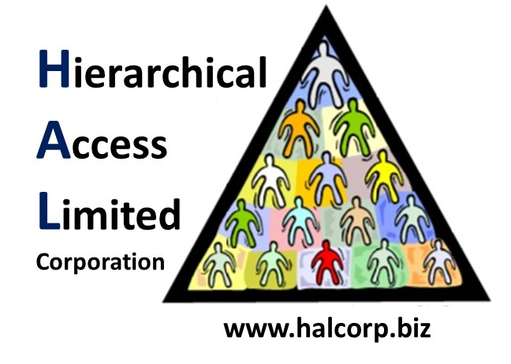

Internal Memorandum

To: Paula Alexander <hal.cio@seccdc.org>

CC: judge_29@seccdc.org

From: hal29@seccdc.org

Date: February 23, 2019

Memo #: 002

Re: Change Control and IR Certifications

Greetings,

In order to have our new team fully trained on HAL policies on Incident Response and Change Control, we have had two team members certified in each. Our personnel that are certified as Regional Change Management Administrators are Michael Roberts and Aiden Durand. Our Incident Response Specialists are Alex Cote and Michael Ibeh. Attached are screenshots of our completed certification tests.

Regards,

Team 9

*In accordance with HAL Memorandum policy, the entire header must be completed or the recipient may not acknowledge this as an official memorandum. Professional communications methods and decorum must be observed at all times.*